Youth Programs  Referral form |  | 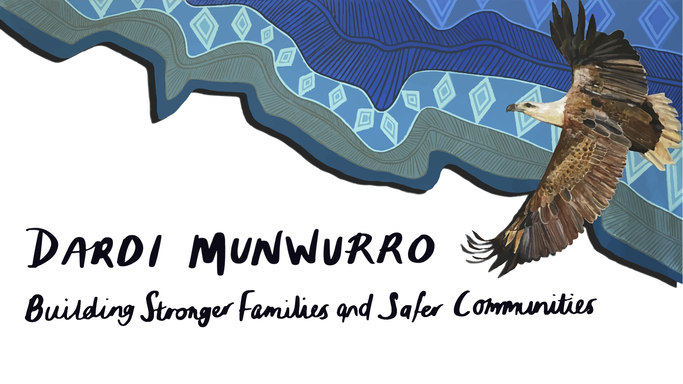

Date of Referral

Young person details

First name |  | Last name
Nickname
Date of birth |  | Age
Address
Postcode |  | Mobile  number
Language group
Email

Guardian/emergency contact details

First name |  | Last name
Address
Postcode |  | Mobile  number
Email

Transport Authority

(If under 16-year-old authority to be given and signed by Parent/Guardian only)
Do you give permission for Dardi Munwurro staff to transport you/your child/ren while attending the program?
Yes | No

Media Release

(If under 16-year-old permission to be given and signed by Parent/Guardian only)
Do you give permission for Dardi Munwurro to use media (photo, video etc.) of you/the young person?

Yes | No

Parent / guardian/self signature:

Referral details

Source of referral

Date of referral

Contact details
- Name
- Mobile
- Email

About the young person

Involvement with other services

Is a young person of youth justice? | Yes | No
Comments

A client of child protection? | Yes | No
Comments
Involved with AOD and/or MH? | Yes | No
Comments

Involved with other services? | Yes | No
Contacts

Living situation (cross one)

Lives with family |  |  | Lives independently
Lives in some type of out of home care |  |  | Does not have fixed address
Comments

Education

Highest completed level of education |  | Currently attending school | Yes | No
School name

Employment

Currently employed? | Yes | No | Length of employment (weeks)
Number of hours worked in past month |  |  | If not currently employed, have you ever had a job? | Yes | No

Interest and hobbies

Reason for Referral

Is the young person experiencing any illness at the moment? | Yes | No
If yes:
- Type of illness
- How long you have had this illness
- What you have been told about how long it might last
- What treatment you are seeking

Permission to contact Young Person – YES / NO

Please contact
Email: Youthservices@dardimunwurro.com.au
Phone: 8456 3044

Referrer name Referrer signature Date Allocated

